# Recruiting Assistant For HR Managers

### Introduction

## Overview :

A Human Resources (HR) Assistant is a professional who is responsible for the daily administrative and HR duties of an organization. They assist with recruitment and record maintenance for payroll processing as well as provide clerical support to all employees.

## Purpose :

A systematic process of finding , identifying , short listing , interviewing and selecting qualified candidates for specific job positions in an organisation . It is an important step in building human captial to meet the overall goals of the organisation .

### Problem Definition & Design Thinking

## Empathy Map:

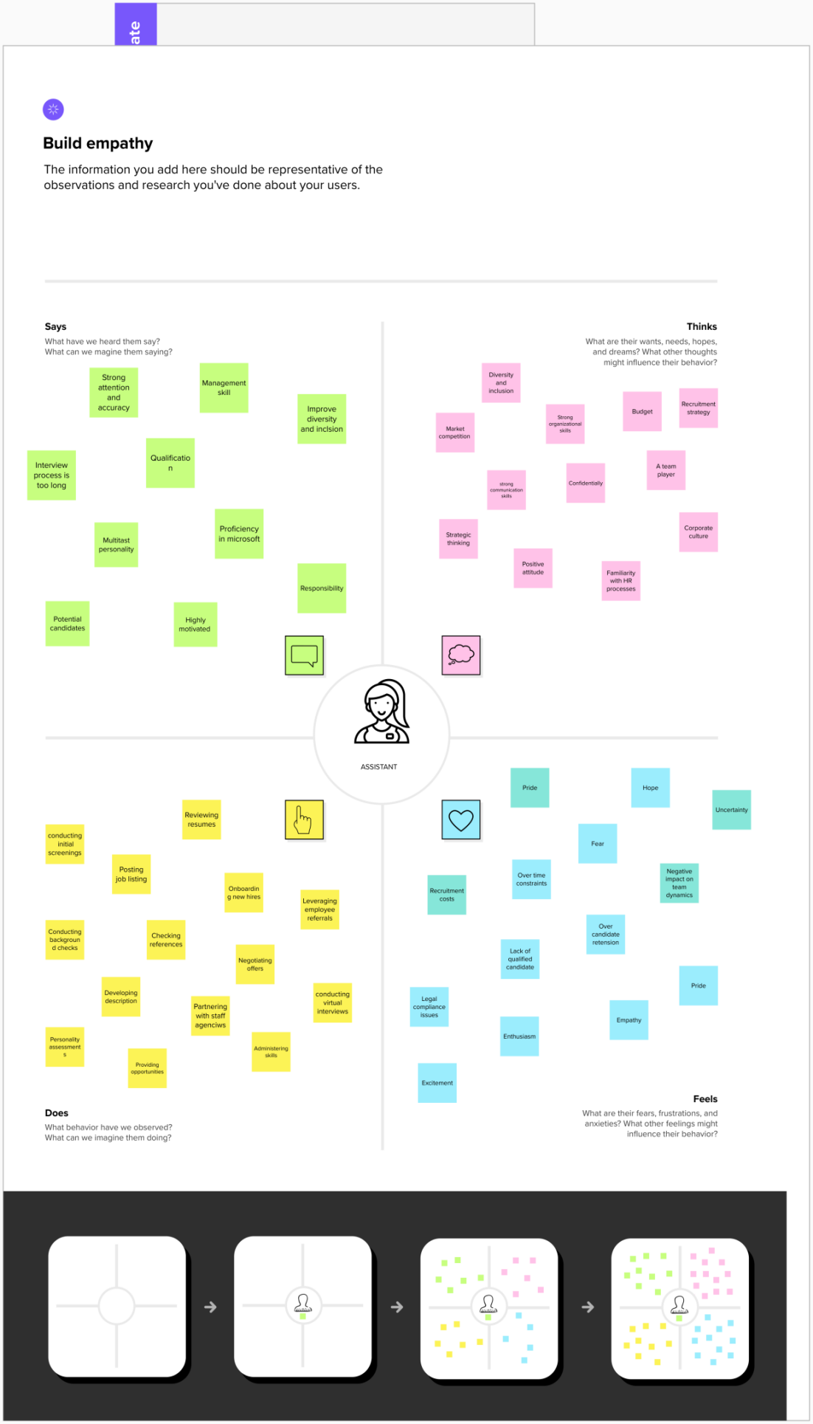

## Ideation & Brainstorming Map :

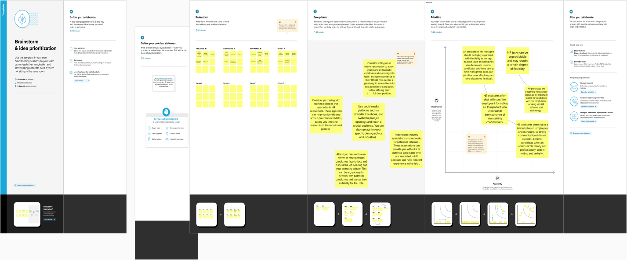

### RESULT

## Data Model :

|  |  |
| --- | --- |
| **Object name** | **Fields in the objects** |
| Job Posting Site | |  |  | | --- | --- | | **Field Lable** | **Data Type** | | Job Posting Site | Text | |
| Review | |  |  | | --- | --- | | **Field Lable** | **Data Type** | | Review | Auto Number | |

## 

### Activity & Screenshot :

## Creation of developer account :

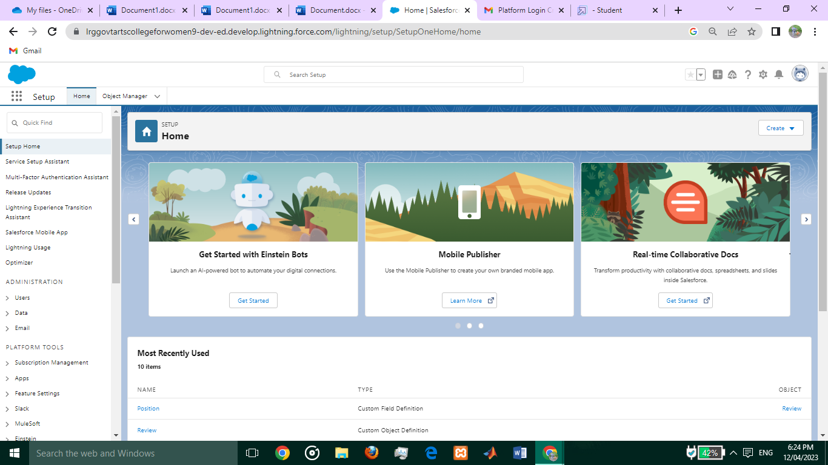

## Package Installation :

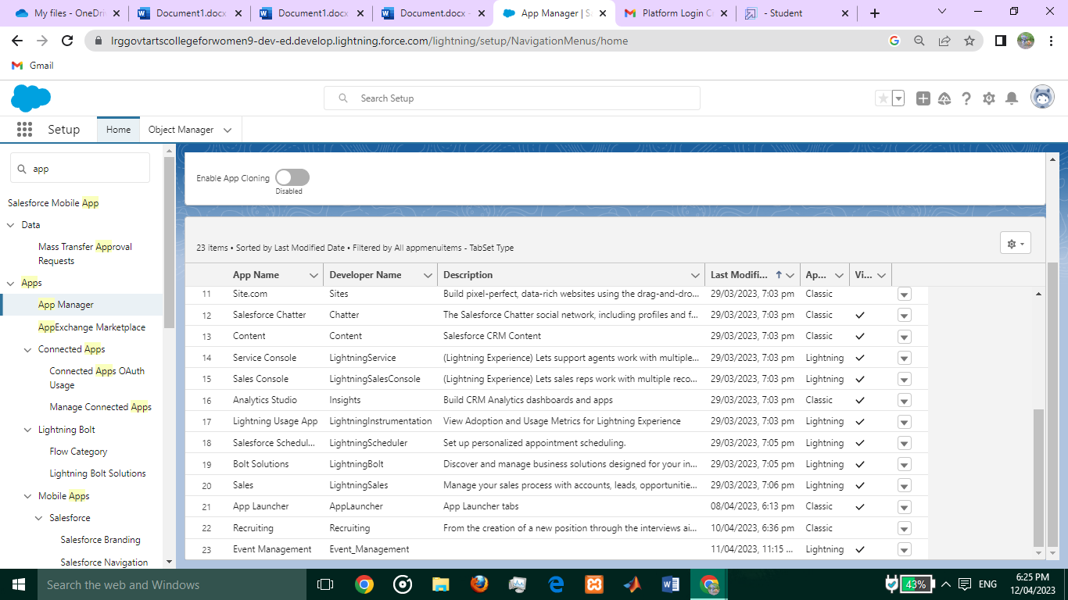

## Object :

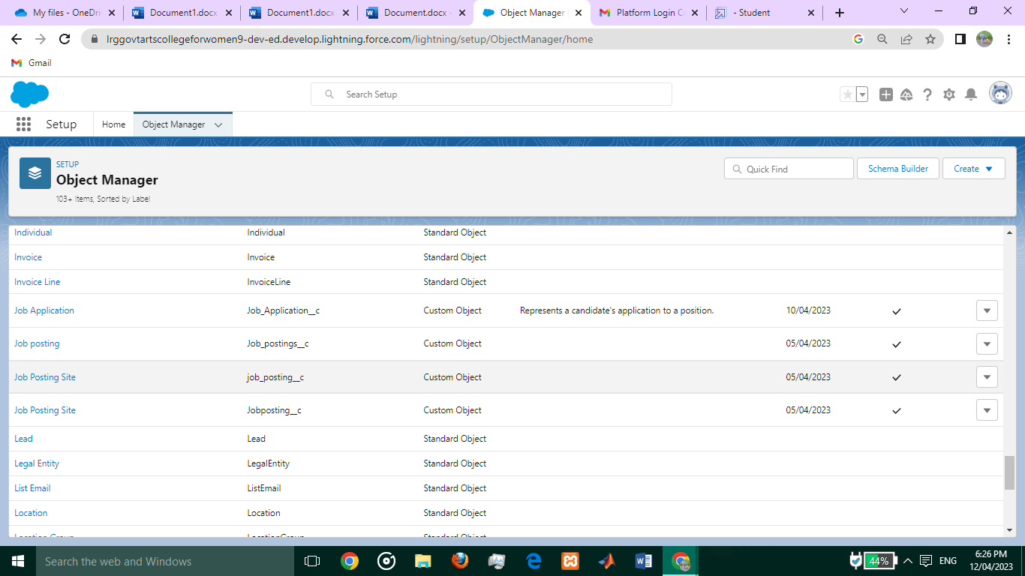

**Job Posting Site :**

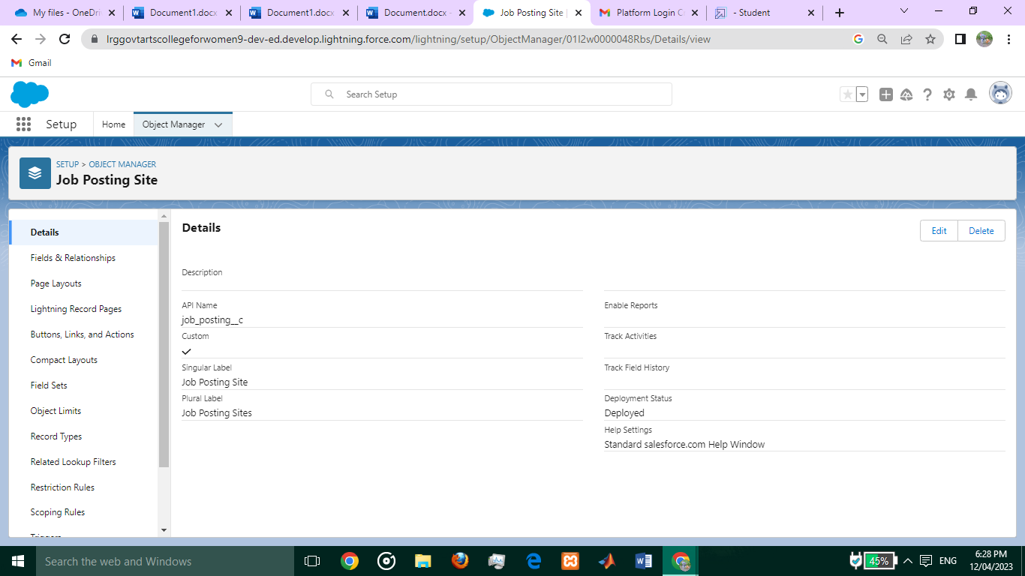

**Review :**

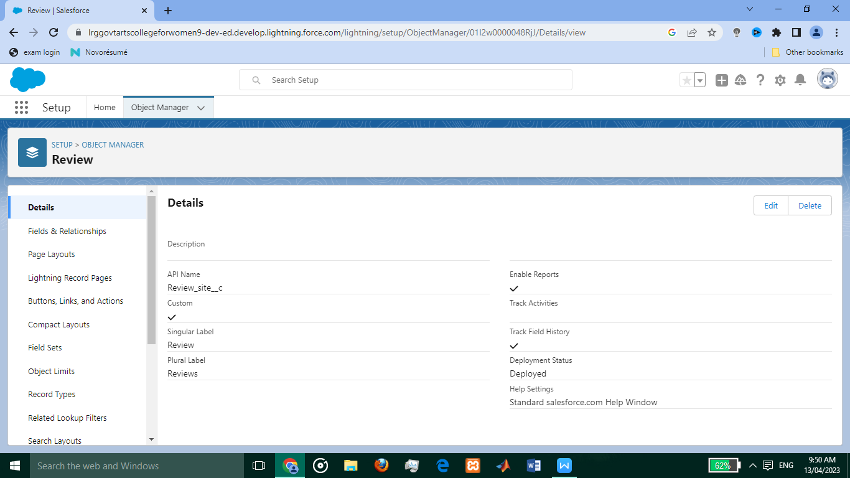

## Tabs :

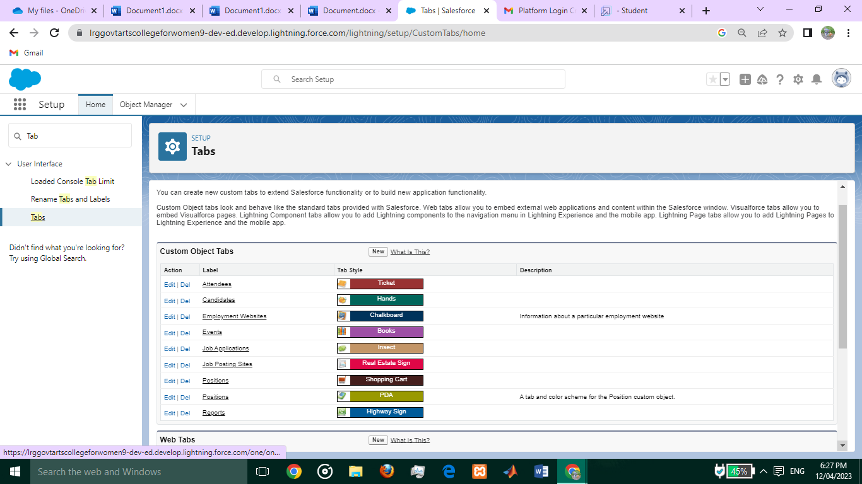

## Fields :

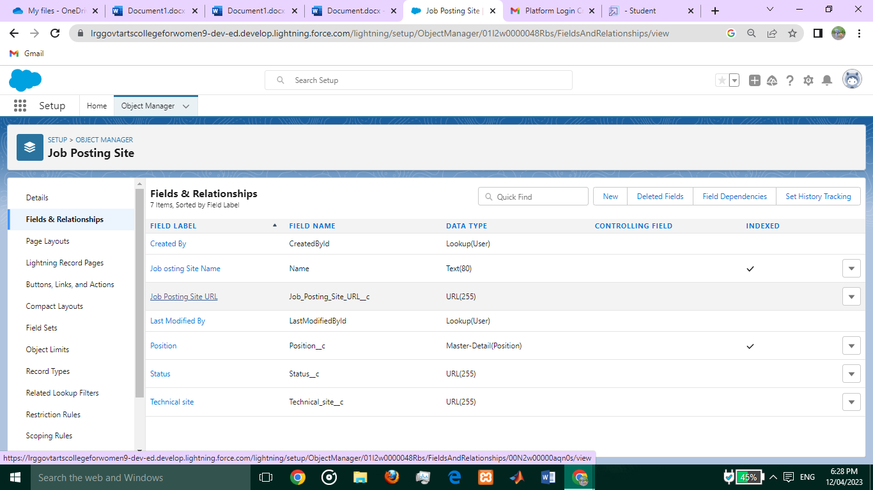

**Job Posting Site :**

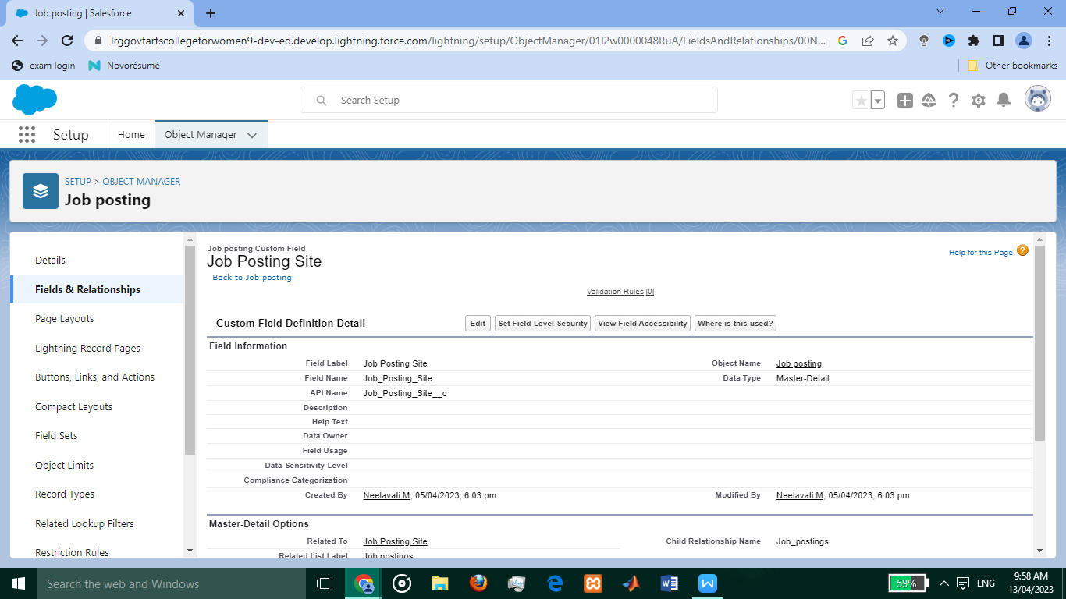

**Status :**

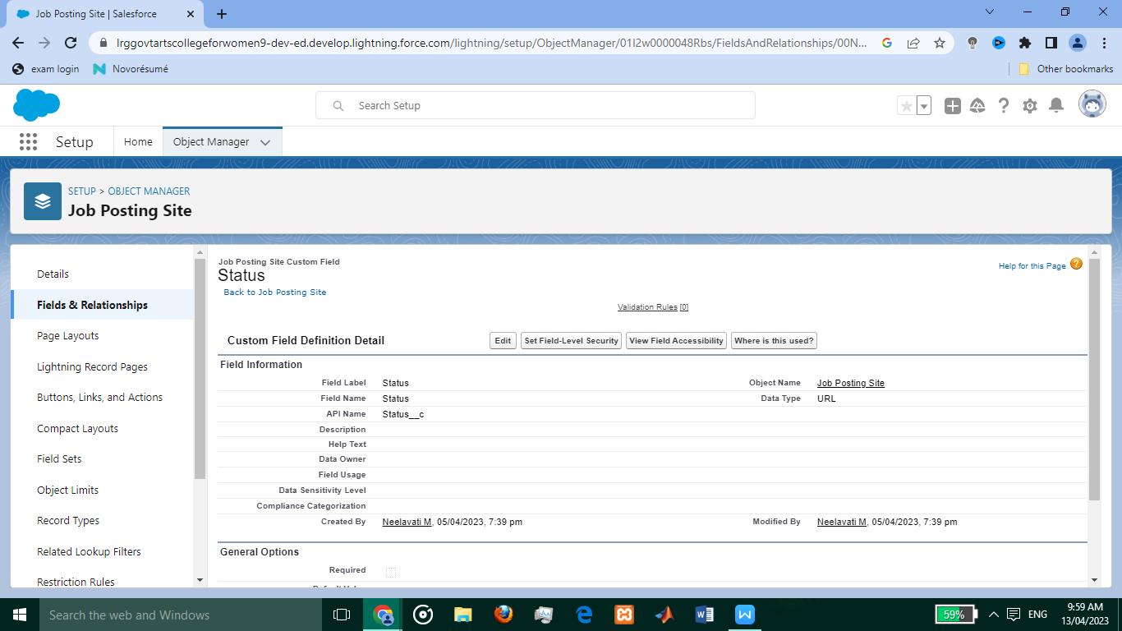

**Technical site :**

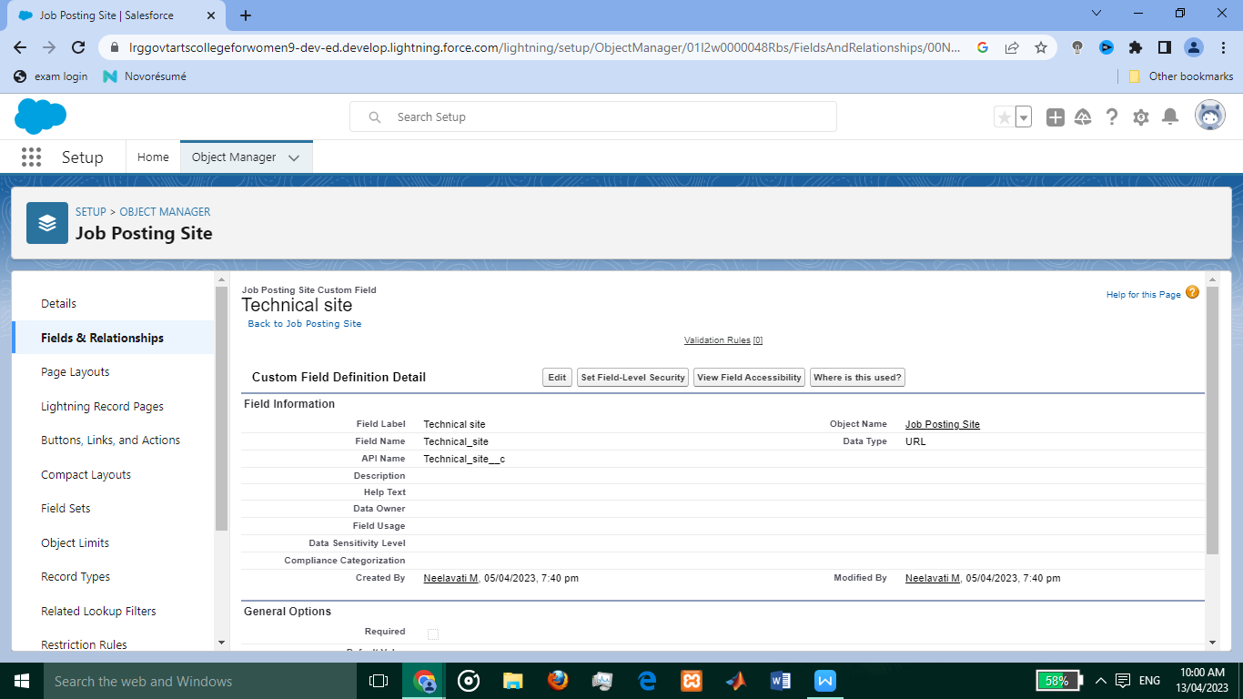

* **Junction Object :**

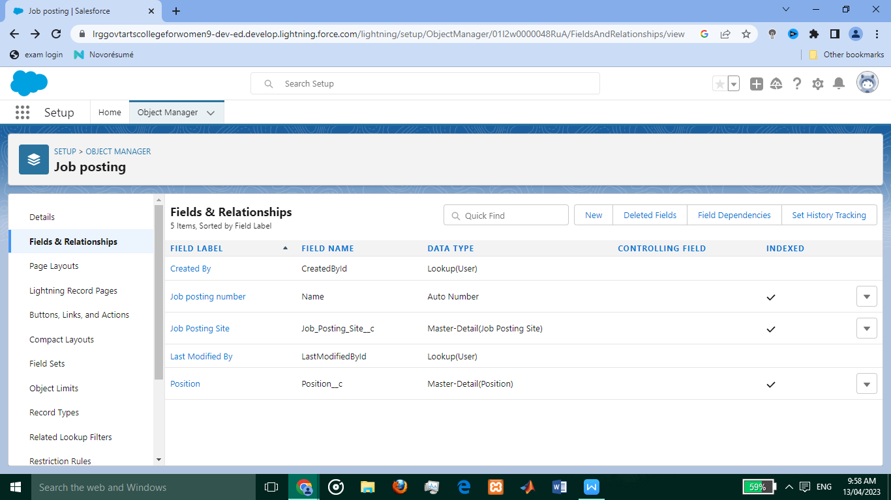

**Relationship Betwween Job posting & Job posting site :**



**Relationship Between Job Posting & Position :**

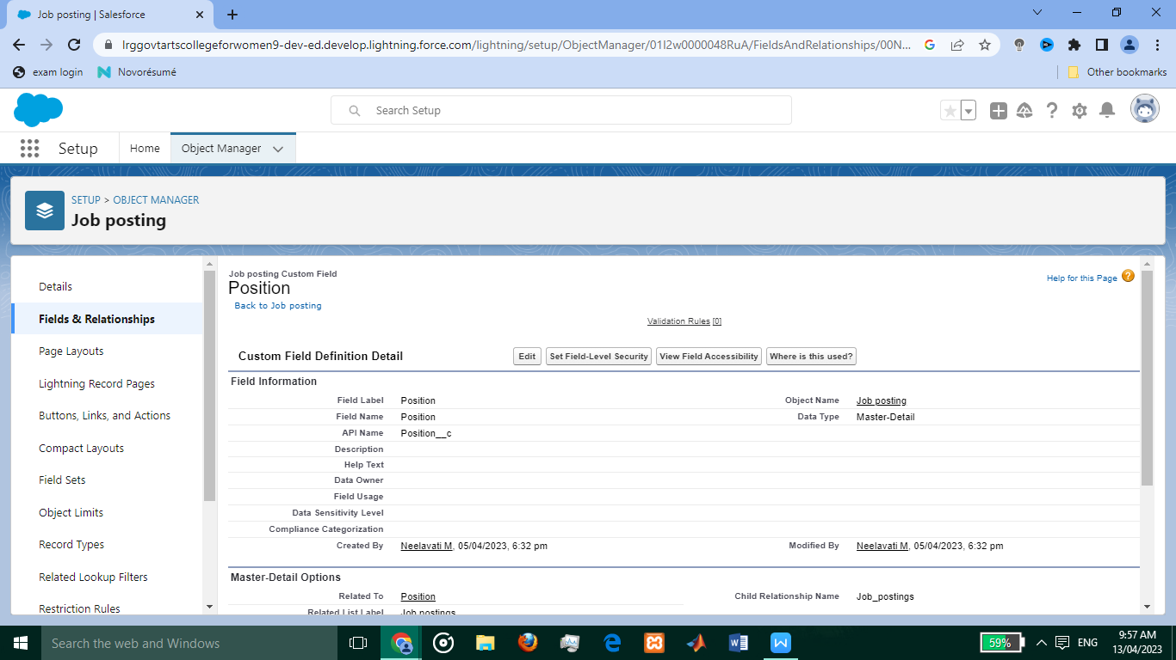

* **Page Layout :**

**Position :**

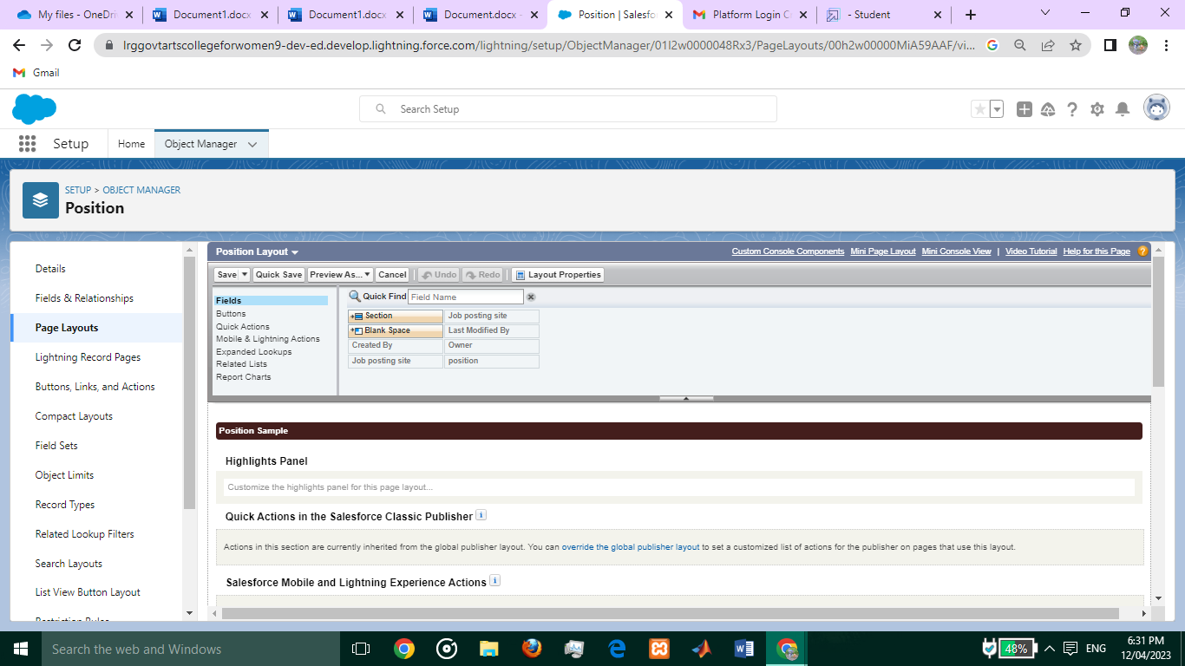

**Review :**

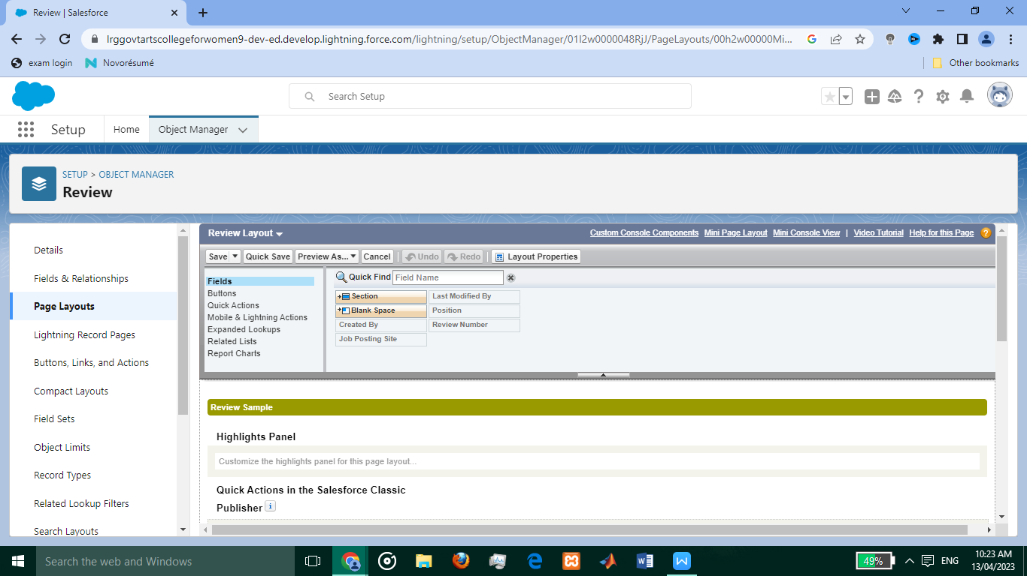

* **Validation Rule :**

**Phone number validation rule :**

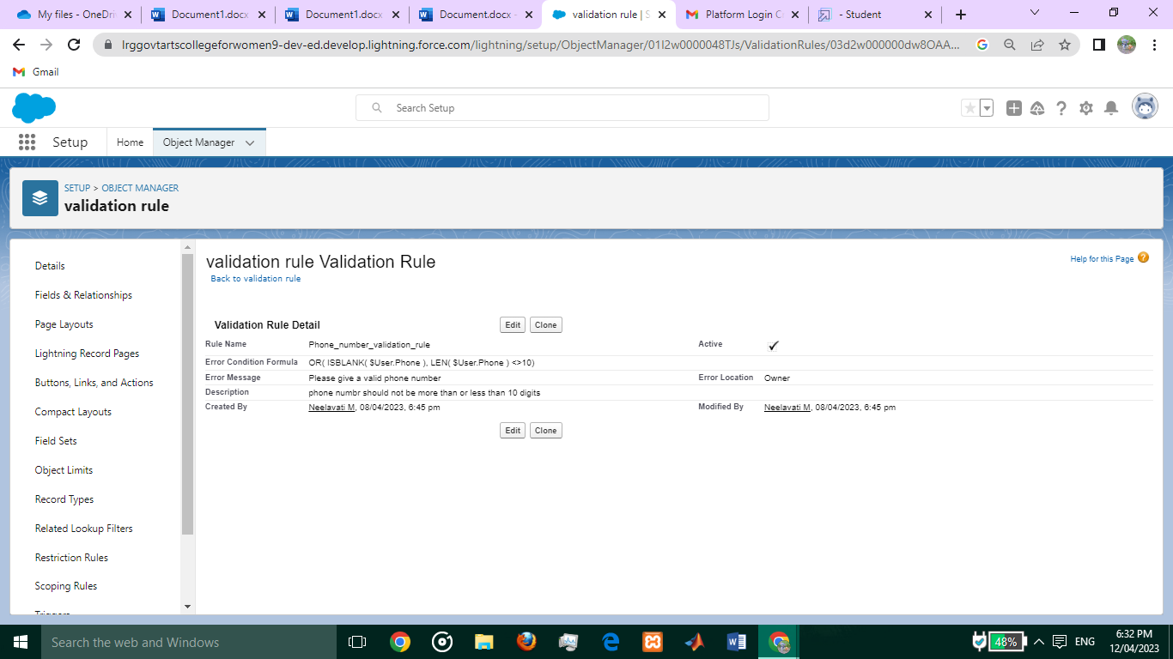

**Technical site :**

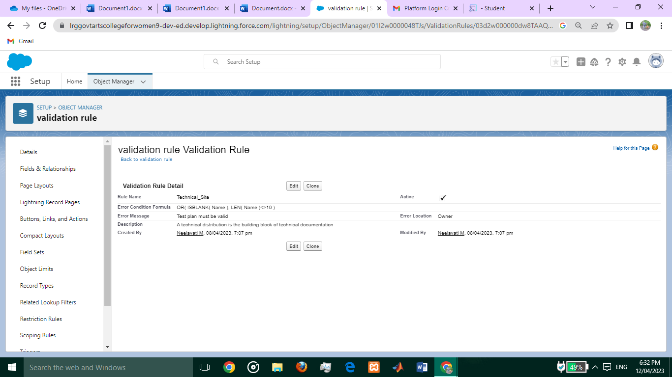

* **Profiles :**

**Event user profile :**

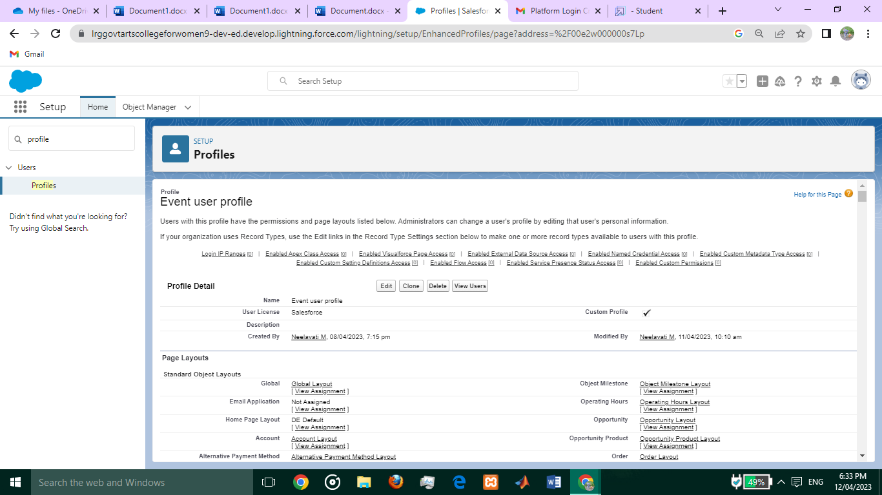

**Sales Profile :**

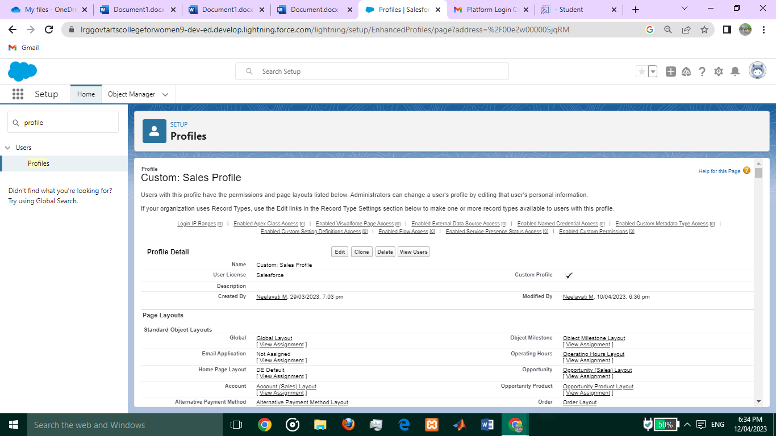

**User :**

**Event user profile :**

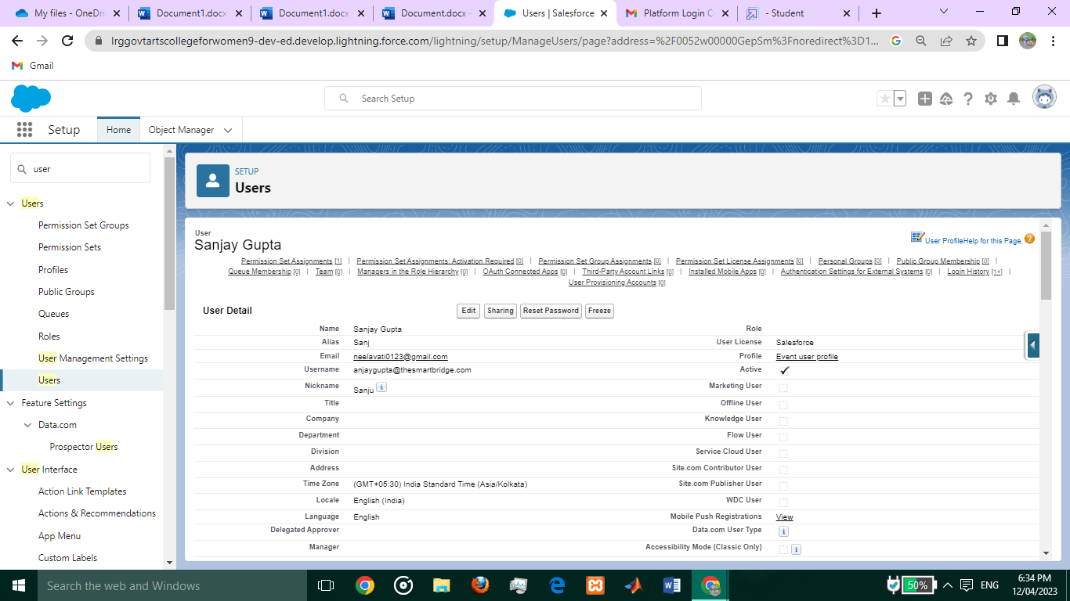

**Sales profile :**

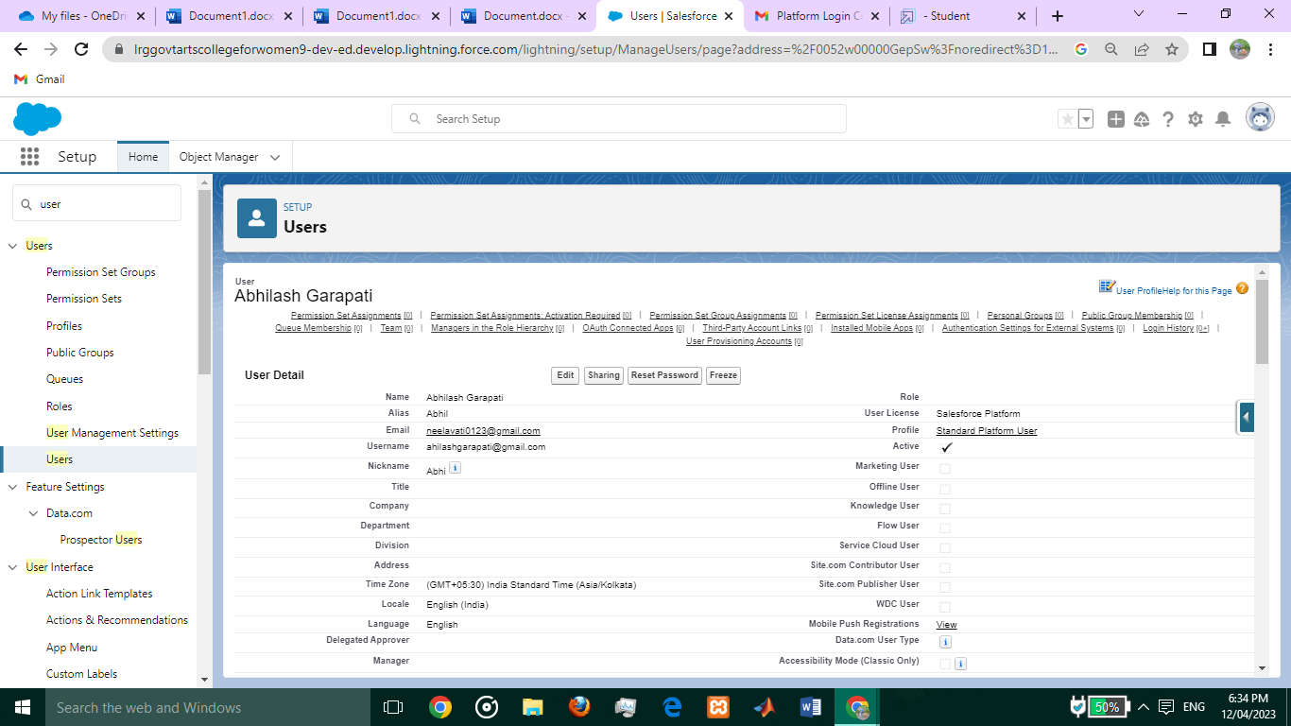

* **Permission Set :**

**Supplier Permits :**

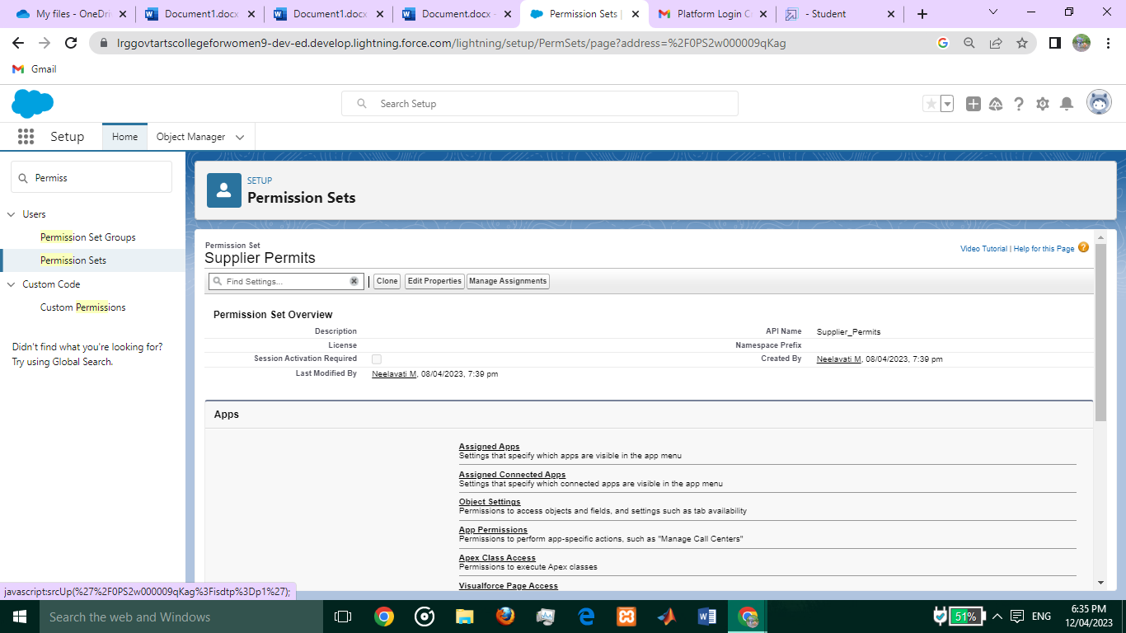

**Review :**

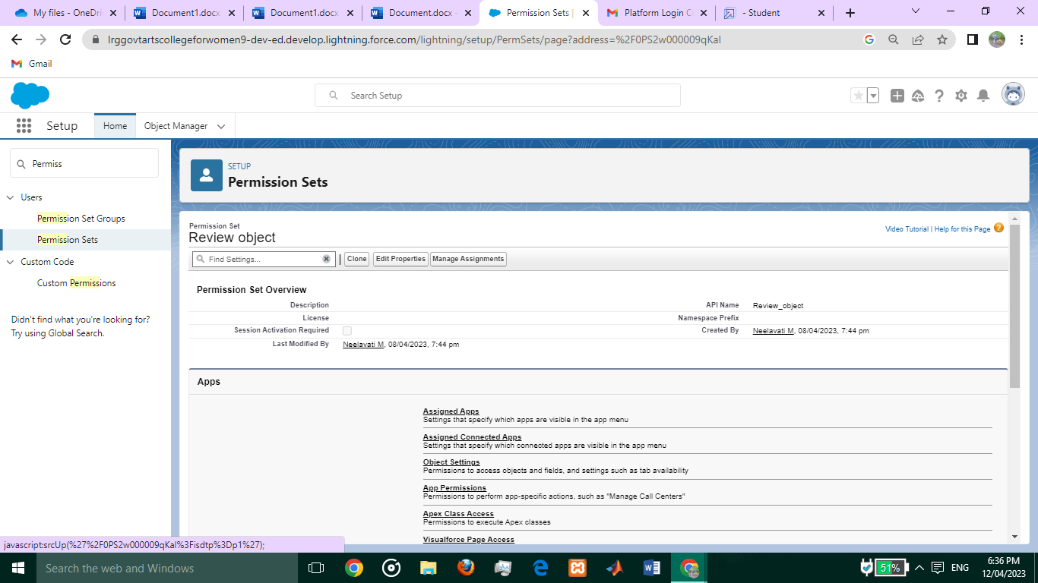

* **Report :**

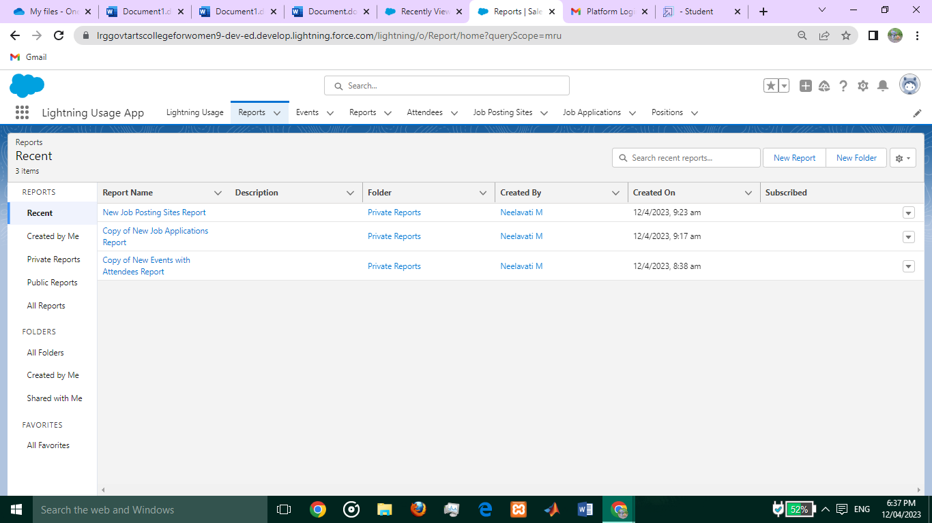

**Attendees :**

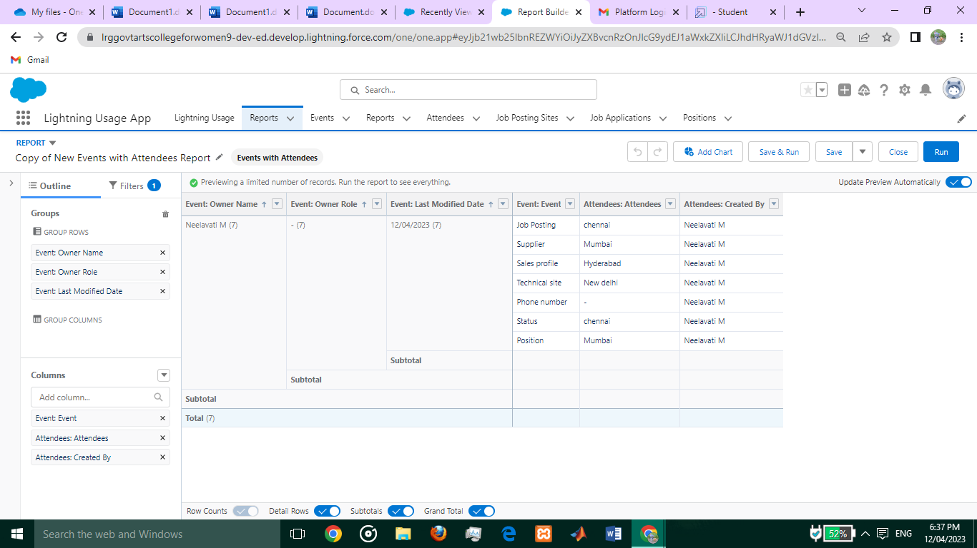

**Review**  :

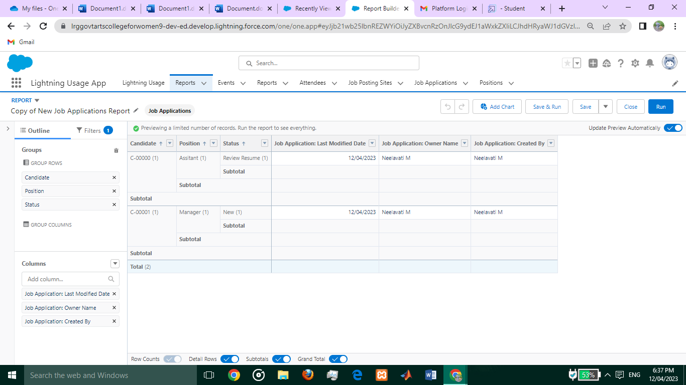

**Job Positing site :**

### Screenshot (30)

### Trailhead Profile Public URL

Team Lead :[https://trailblazer.me/id/neelm25](https://trailblazer.me/id/neelm25" \t "https://mail.google.com/mail/u/0/" \l "inbox/_blank)

Team Member 1 :[https://trailblazer.me/id/kalat8](https://trailblazer.me/id/kalat8" \t "https://mail.google.com/mail/u/0/" \l "inbox/_blank)

Team Member 2 :[https://trailblazer.me/id/kavym14](https://trailblazer.me/id/kavym14" \t "https://mail.google.com/mail/u/0/" \l "inbox/_blank)

Team Member 3:[https://trailblazer.me/id/mythr41](https://trailblazer.me/id/mythr41" \t "https://mail.google.com/mail/u/0/" \l "inbox/_blank)

## ADVANTAGES :

Reduce time to hire : They’re prescreened for culture fit . Their track record is easily accessible .

They may not always need full interiviews with managers .

Shorten onboarding times : Know how your company operates and most of your polices and practices . May be familiar with people in their new team , especially in smaller businesses .

Cost less : Post ads on job boards

Subscribe to resume databases

Pay for backgrounds checks .

Strengthen employee engagement : Promoting from within sends a message that you value your employees and want to invest in them . Giving employees more opportunities to advance their carreers , or even letting them move to other same level positions .

### DISADVANTAGES :

Create resentment among employees and managers : Employees who were considered for a role could feel resentful if a colleague or external candidate is eventually hired . Managers are often uncomfortable losing good team members and may even go so far as to hinder the transfer or promotion process .

Leave a gap in your existing workforce : When you promote someone to fill an open position , their old position becomes vacant . This means that a series of moves and promotions may ensue that could distrupt your business’ operations .

Limit your pool of applicants : While your company may have a lot of qualified candidates for specific positions , this isn’t necessarily true for every open role .

Result in inflexible culture : An infexible culture will be more problematic in leadership positions where employees may need to advocate for change and improvement instead of relying on established , inefficient practices . External hires are essential in shaking up culture and offering a fresh perpective on existing problems .

### APPLICATIONS :

* Assist with day to day operations of the HR functions and duties.
* Provide clerical and administrative support to Human Resources excutives.
* Compile and update employees records(hard and soft copies) .
* Process documentation and perpare reports relating to personnel activities(staffing , recruitment , training , grievances , performance , evaluations etc ).
* Communicate with public services when necessary .
* Assist our recruiters to source candidates and update our database .

### CONCLUSION :

An effective recruiting assiatant process reduces turnover , we also get much better resuits in our recruitment process if we advertise specific criteria that are relevant to the job . Include all necessary skills , and include a list of desired skills that are not necessary but that would enhance the candidate’s chances .

### FUTURE SCOPE :

The future of recruiting departments will need to upskill , track new metrics , annd adopt new technologies . They will need to take on a more visible , strategic role within the business and will seriously rethink the way they see their job .

### 

### 